Join Mr. Criscolo and nVent ERICO to learn how to install nVent ERICO Cadweld

During this hands-on training, participants will make their own nVent ERICO Cadweld connections. Training will cover the history of nVent ERICO Cadweld, required tools, materials, PPE and safety requirements, as
well as proper mold preparation and the complete installation process. Installation tips and guidelines will also be covered for proper installation, visual inspection and troubleshooting techniques. At the successful completion of the training, attendees will receive a card from nVent ERICO documenting your participation in nVent ERICO Cadweld training , a hard hat decal and an official Certificate of Completion valid for two years.
Monday April 10, 2023 @ 4pm to 5pm (40 max) & Wednesday April 12, 2023 @ 4pm to 5pm (40 max)
Register through Flashpoint via CMS (CLASS NEWS AND ANNOUNCEMENTS) FIRST COME, FIRST SERVE
FIRST COME FIRST SERVE

Our powerful portfolio of brands:

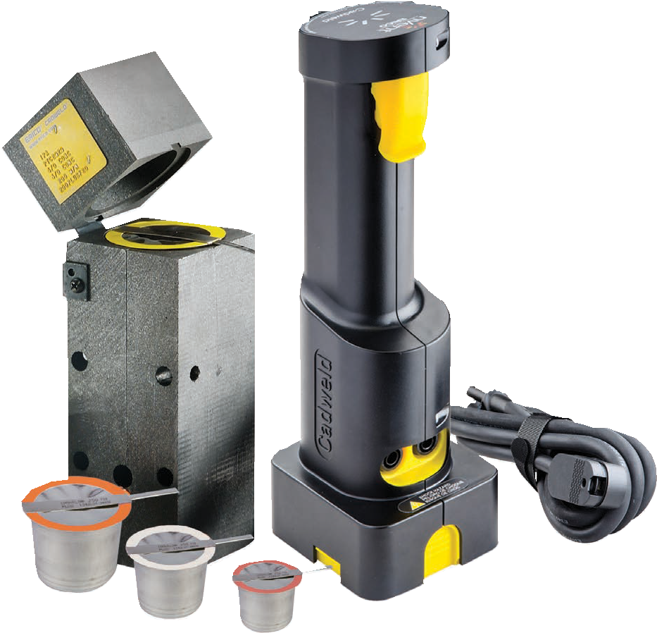
©2022 nVent. All nVent marks and logos are owned or licensed by nVent Services GmbH or its affiliates. All other trademarks are the property of their respective owners. nVent reserves the right to change specifications without notice.
ERICO-FLY-H88618-CadweldTrainingMars-USEN-2210

nVent.com/ERICO

